QA TRAINING NOTES

Bug: Error in computer application that causes an incorrect or unexpected results. Application behaves in an unintended way.

Categories defects/bugs in frontend:
- Layout
- Font
- Color
- Content
- Images.

Types of testing:
Black box testing (Functional testing):
Testing which involves user action and expected reaction from the application.

Compatibility testing:
Testing involves testing the application works well with various type of operation systems, difference devices, different types of browsers, network etc.

Localization testing
Testing involves validation of application’s behavior according local culture or settings.
Eg 1. Option to change language and actually see the accurate effects.
2. Currency change.
3. Date and time format.

Performance testing
Testing involves determining the speed, responsiveness and stability under a work load.

Usability testing.
Testing involves method used to determine how user friendly the application is or how easy to use the website is.

Security Testing.
This involves testing to determine if the system/application is secured from hackers and if the information system protects data.

Monkey Testing / Adhoc testing
When test is done randomly.

Gray box testing
Testing involves bit of functionality and internal testing (a bit of code testing)
Eg. Integration testing.

White box testing
This involves the knowledge of the internal code, Testing the code logic and for loops.
Eg Unit testing by developers, loop testing.
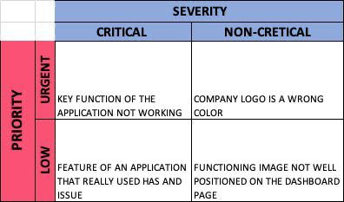

How to write test cases

1. Preconditions. E.g. User must be on login screen
2. Steps to achieve goals E.g. User inputs valid credentials
3. Expected results.
4. Actual results.

Smoke testing
Small amount of testing to ensure important functions of the application work.

Test Plan
What describes the application testing scope and activities.
Helps with structuring and planning.

